2023/2024 Coach Development Schedule

Joining the coaching family?

Which is the right programme for you?

Includes course info, dates, venues & booking links

Who is it for?

Anyone aged 16 and over wishing to support qualified coaches, inspire players and make a difference to the game.

This programme has been designed to give learners the knowledge, skills and confidence to support qualified coaches.

An ECB Support Coach is not qualified to lead coaching sessions independently and therefore must be supervised by a qualified cricket coach.

What commitment does the programme require?

- £40.00

- 1 face-to-face module lasting 3 hours

- 2 bitesize e-learning modules lasting 10-15 minutes each

- Multiple choice question assessment

Content

- Supporting coaches and players

- Communicating with coaches and players

- Supporting fielding, bowling and batting

- Safety

- icoachcricket

What are the prerequisites for certification?

- 16 years of age

- Valid ECB DBS

- Valid safeguarding training

What learning opportunities can be accessed after the programme?

Full membership of the ECB Coaches Association and ECB Foundation Coach or ECB Core Coach

Certificate – Downloaded from ECB Portal on completion.
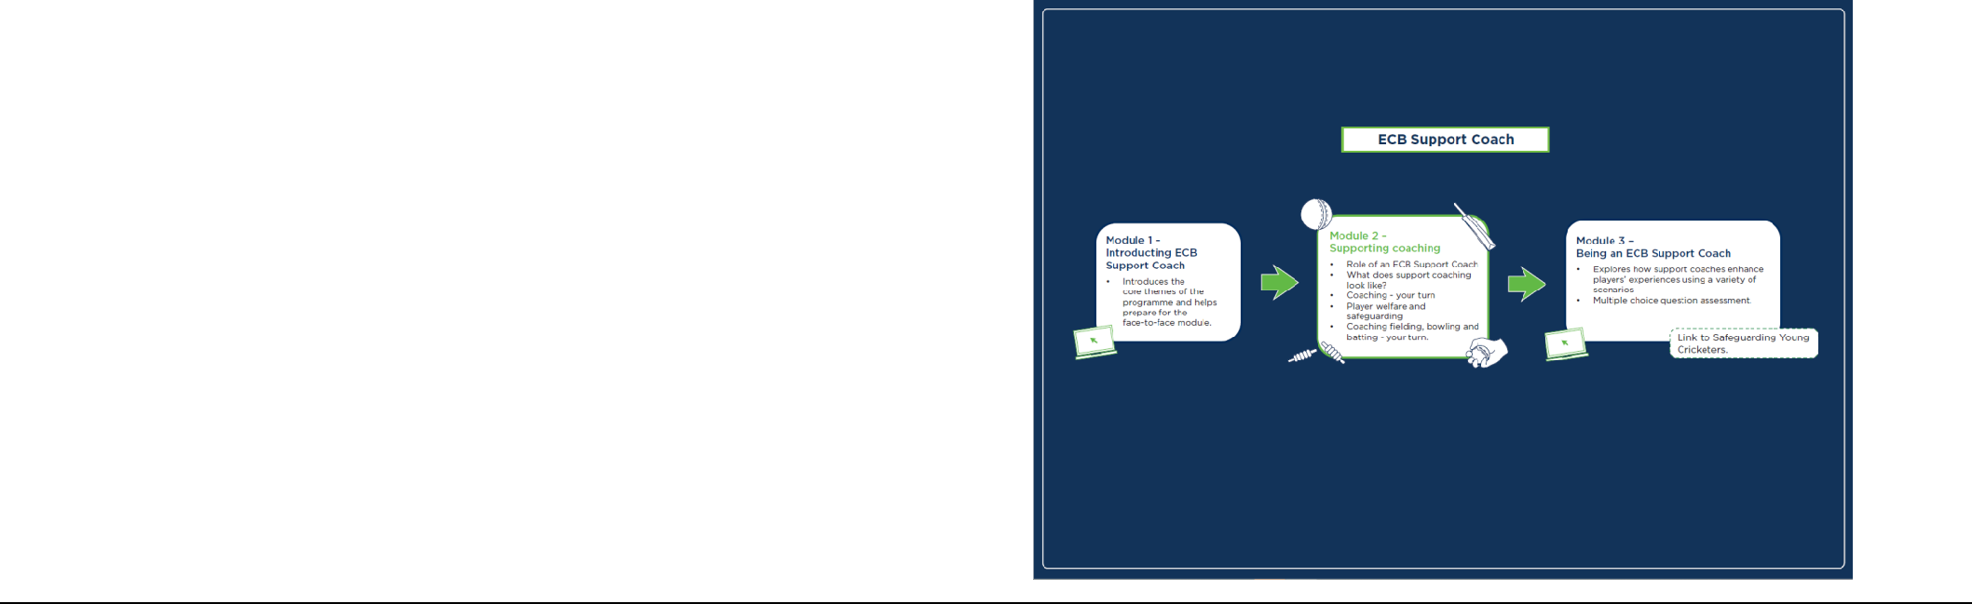

Who is it for?

Anyone aged 17 and over wishing to become qualified to coach cricket, inspire players and make a difference to the game.

This programme has been designed to give learners the knowledge, skills and confidence to coach cricket sessions that are purposeful, active, safe and enjoyable.

An ECB Foundation Coach will be qualified to lead coaching sessions independently and without supervision.

What commitment does the programme require?

  - £150.00

- 4 face-to-face modules lasting 3 hours each including 2 observed

coaching opportunities & 7 bitesize e-learning modules lasting 15-20 minutes each

• Multiple choice question assessment

Content

- Role of an ECB Foundation Coach

- icoachcricket

- What does coaching look like?

- Coaching fielding, bowling and batting

- Foundation principles – fielding, bowling and batting

- The coaching tools, Differentiation & Safety

What are the prerequisites for certification?

- 18 years of age

- Valid ECB DBS

- Valid safeguarding training

What learning opportunities can be accessed after the programme?

Full membership of the ECB Coaches Association and ECB Core Coach.

Certificate - Issued by 1st4Sport via post.
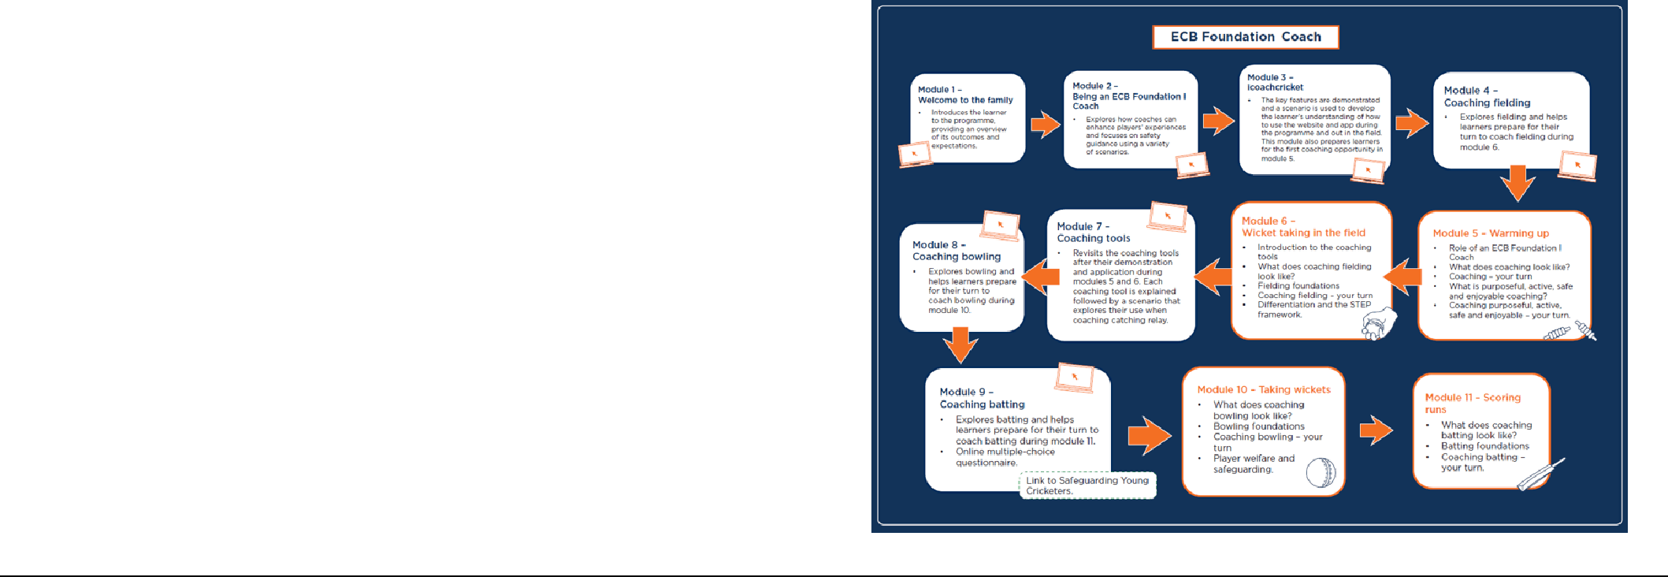

Who is it for?

Anyone aged 17 and over wishing to become qualified to coach cricket, inspire and develop players and make a difference to the game.

Experience of playing or coaching cricket is desirable but not essential when applying for this programme.

This programme has been designed to give learners the knowledge, skills and confidence to lead player-centred coaching sessions.

An ECB Core Coach will be qualified to lead coaching sessions independently and without supervision.

What commitment does the programme require?

- £300.00

- 8 face-to-face modules lasting 3 hours each including 2 observed coaching opportunities & 6 bitesize e-learning modules lasting 15-20 minutes each

- Multiple choice question assessment & Short answer question assessment

Content Includes:

- Player-centred planning process, Player development & Coaching Tools

- Core principles – batting, bowling (pace and spin), fielding and wicketkeeping

- Tactical knowledge, physical fundamentals and mental skills

- Differentiation, Safety, The continuum of practice.

- Role of an ECB Core Coach & icoachcricket

What are the prerequisites for certification?

- 18 years of age

- Valid ECB DBS

- Valid safeguarding training

What learning opportunities can be accessed after the programme?

Full membership of the ECB Coaches Association & ECB Advanced Coach.

Certificate - Issued by 1st4Sport via post.
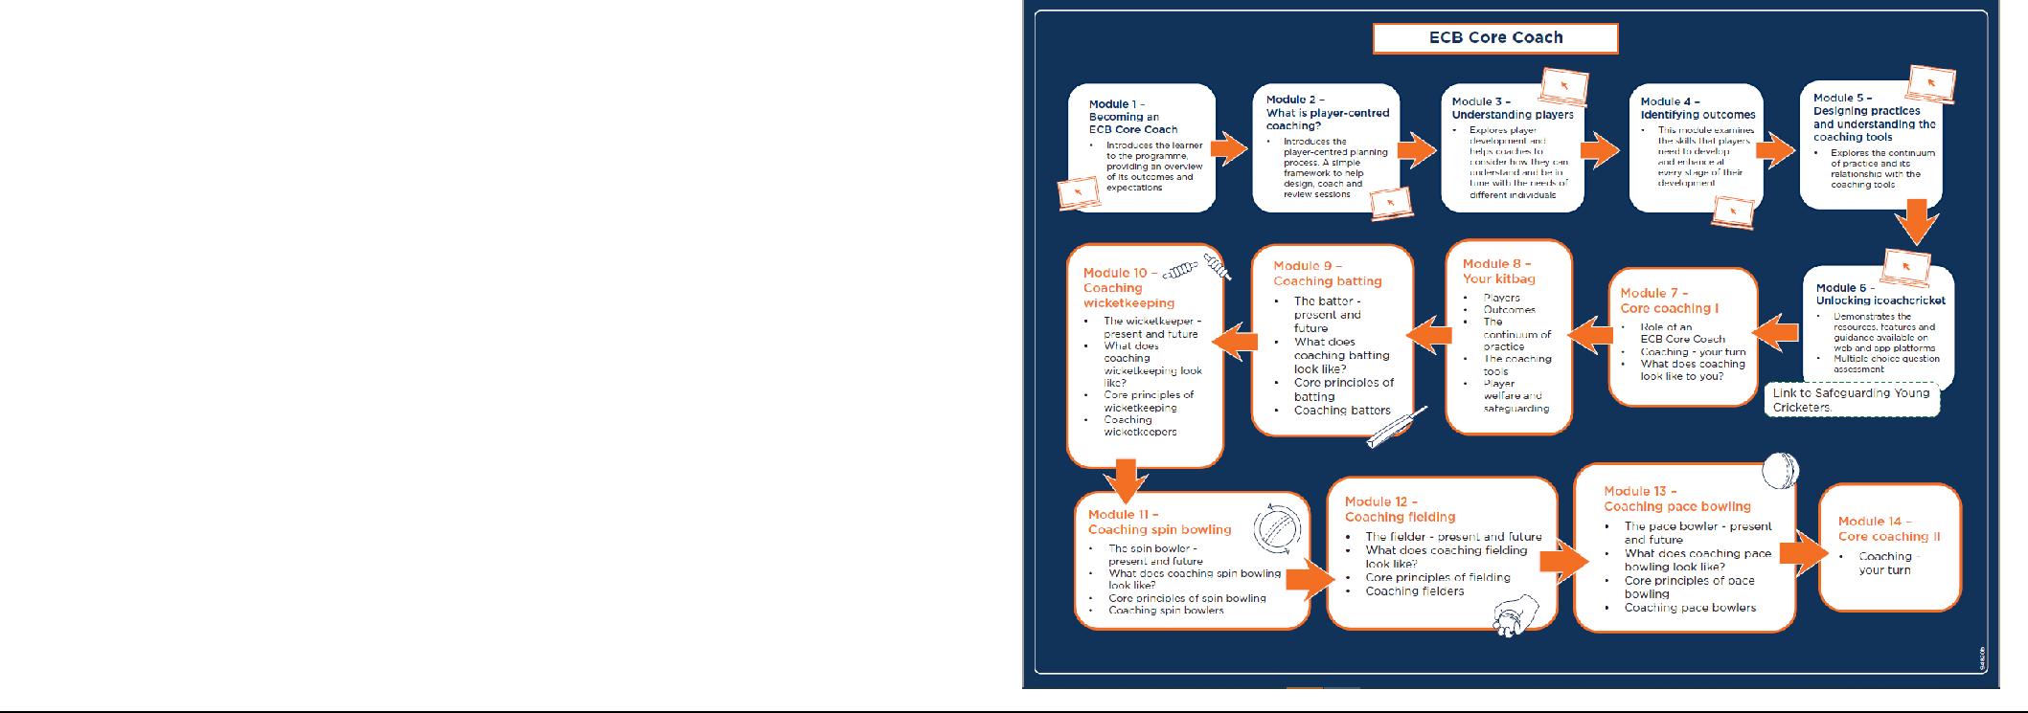

Our courses 2023/2024:

ECB Support Coach – we will be running one of these early in the 2024 season for prospective Support Coaches.

ECB Foundation I Coach
 |  |  |  | Dates |  |  |  | Time |  | Venue |  |  |  | Booking Link
 | ECB Foundation Coach -24 |  |  | TBC

ECB Core Coach

 | Dates |  | Time | Venue |  | Booking Link
ECB Core Coach | TBC

First Aid

First Aid courses are advertised throughout the year on our website and through social media.

We can also organise a course to be held at your club if you have 8-12 learners.

Contact about anything please call 01432 275189 – or email us on PentlandGardensBooking@herefordshirecricketltd.co.uk for more info.

Bursaries for Coaching

Coaching is a challenging and enormously rewarding role within our game. Players need expertise, support and passion at every level of their development. No matter whether you are putting something back into the game you love, progressing your career, helping out at your local club, or simply providing more support to your child, there is a reason for everyone to get involved in cricket coaching.

Bursaries funded by the generous support provided by Liverpool Victoria General Insurance Group Limited to the England and Wales Cricket Trust are intended to increase the diversity of learners taking their first step into coaching, gaining a qualification or taking the next step on their coach development journey.

Groups that have been identified to increase the diversity of learners accessing coach development programmes are:

- Potential coaches/coaches that are female

- Potential coaches/coaches from ethnically diverse communities

- Potential coaches/coaches with a disability

- Potential coaches/coaches experiencing financial hardship.

A bursary can be awarded to learners that register on ECB Support Coach, ECB Foundation Coach or ECB Core Coach programmes between 1st February 2023 and 31st January 2024.

Anyone wanting to access coach development that is experiencing financial hardship will be awarded a bursary of up to 100% of the national price of the programme.

Once an applicant receives confirmation they will need complete their programme registration using a discount code to redeem their bursary.

Anyone wanting to access coach development that is female, from an ethnically diverse community, has a disability who is not experiencing financial hardship will be awarded a bursary of up to 75% of the national price of the programme.

Once an applicant receives confirmation they will need to complete their programme registration and make full payment and upon certification receive a refund to redeem their bursary.

Bursary Applications

Application forms and more information can be found on our website: https://www.herefordshirecricket.co.uk/news/new-bursaries-announced/

Please note if you are experiencing financial hardship and applying for a bursary you will need a discount code to complete your ECB Support Coach/ECB Foundation Coach/ECB Core Coach registration. This code will be sent to you once we have accepted your application.

Once an application is submitted, we will email all candidates to explain the next steps. Please contact kirstysockett@herefordshirecricketltd.co.uk if you have any bursary related questions.

Coach Development Courses Cancellation Policy

- More than 21 days before course commencement, 90% refund - 10% admin fee charged

- Within 14 - 21 days of course commencement, 50% refund.

- Less than 14 days prior to course commencement, no refund available

- Places are non-transferrable.

FAQ

Can I register someone else on the course?

No, due to GDPR, each learner must register themselves for courses.

An ECB DBS is a course requirement, I don’t have one, how do I get one?

Once registered, your ECB DBS status will be checked. If you don’t have a current ECB DBS, don’t worry, we will initiate the process for you.

How will I receive my certificate?

Certificates for Foundation Coach & Core Coach will be sent via post 14 days after course completion by the awarding body, 1st4Sport. Certificates for Support Coach can be downloaded from the ECB E-Learning Portal. Certificates will not be issued until all course requisites have been met, including DBS and online modules.

I can’t attend all the dates for the Foundation Coach or Core Coach, can I attend a different course at a later date to complete the modules?

No, you must be available for all the dates on your chosen course. Please do not book on a course unless you can attend all dates.

These dates don’t suit me, can I attend a course in another county?

We’d love you to start or continue your coaching journey with us here in Herefordshire, but yes, other counties may be running the same courses on different dates and times or in different formats that are a better fit for you. Please contact other county boards directly for more information.

How old do I have to be to attend the courses?

ECB Support Coach – you must be 16 or over.

ECB Foundation Coach & Core Coach – 17 year olds can attend but will not receive their certificate until they turn 18.

COACH and PLAYER DEVELOPMENT WORKSHOPS 2024

Workshop Evenings 1-4 will be held at St Mary's RC High School - Contact Us (st-maryshigh.hereford.sch.uk)
Workshop 5 will be held at Pentland Gardens HR4 0TN

1 Tues 9 Jan 7-930pm
Improving your Demonstrations (1) (IYD1)
This workshop will help and support coaches with a blend of theory and practice. It explores issues associated with communicating by using technical models and your personal demos. During the 2.5-hour session we will cover batting (grips, stances, backswings, forward drives and defence, back foot defence and drive, basic bowling actions and more info on throwing techniques).In particular we will cover the effect of ‘shaping’ shots and actions and also how you link together bits of technique known as ‘chaining’. Most of all how you can apply these to your school and club coaching sessions.
This is aimed to support the Level 1 (Foundation) coach, provide a refresher, and add extra depth in technical knowledge for Level 2 (Core) coach or indeed as a taster for someone that wants to get in to coaching but wants to see what its all about.

2 Tues 30 Jan 7-930pm
Improving your Demonstrations (2) (IYD2)
This workshop will help and support coaches with a blend of theory and practice and will build on IYD1. Please note it is DESIRABLE that you have done IYD1 before you attend this one. It explores issues associated with communicating by using technical models and your personal demos. During the 2.5-hour session we will cover the all-important aspects of batting including the Pull Shot, Pulling against Pace, Moving out to drive to play spin. Bowling the off spinner and arm ball, leg spin and googly and then finishing with an array of fielding centring on the crow hop and throw from the deep (how to throw long distances).
This is aimed to support the Level 2 (Core) coach, provide a refresher and add extra depth in technical knowledge for Level 2 coach or indeed as a taster for someone that wants to get in to coaching but wants to see what it’s all about.

3 Tues 20 Feb 7-930pm
Practical Solutions to Common Problems (PSTCP)
This workshop is an enjoyable needs analysed interactive session designed to equip coaches with an effective range of methods for addressing organisational and technical ‘problems’ commonly encountered with recreational up to semi-professional players. This will provide challenges and solutions to coaches across the board whether they be newbies Support, Foundation. Core or Specialist Coaches in the game i.e. (Levels 1 to 3)
Covering issues such as Stance Bat Path, Hitting from solid bases – front foot and back foot, playing swing bowling, slip catching well, wicketkeeping standing back vs standing up, run ups and no balls, slower balls. A workshop that has it all and is ‘real’ coaching.

4 Tues 9 April 7-930pm
Introduction to Video Analysis (ITVA) CLASSROOM NEEDED AS WELL
These days everyone is taking photos and videos of Cricket and Cricketers but do they actually know what they are looking at when trying to help players ? This course is to familiarise parents players and coaches with basic observational, analytical and evaluation skills using video. The course has video lecture and group discussion to introduce everyone to simple systems for the analysis of batting and bowling techniques.
Primarily designed to form a bridge between new, Level 1 and Level 2 coaches but it also provides a refresher for more experienced cricketers and coaches and is most effective when combined with the Introduction to Net Coaching Module.

5 Tues 23rd April at Pentland Gardens
Developing Net Coaching
A practical session which explores analytical and communication skills required to run a safe and effective net session. Aimed at players and coaches or potential coaches this is a key course to get the best out of your coaching nights at clubs etc and familiarises everyone about other issues that are relevant to the net environment. Examples shown on the night will be – Coaching Net, Analysis Net, Running Net, Nomination Net, Dismissed Net, Open Net and Teaching Net.
Maximum benefit will be gained on this one if you have attended the Intro to Video Analysis Workshop.

To book onto the course please use these links:
Cost - Early bird price £15 per session or £50 for all 5 for bookings before 1st January.
Thereafter £20 per session and £60 for all 5.
Book here for Tuesday 9th January 7.0-9.30pm
Book here for Tuesday 30th January 7.0-9.30pm
Book here for Tuesday 20th February 7.0-9.30pm
Book here for Tuesday 9th April 7.0-9.30pm
Book here for Tuesday 23rd April 7.0-9.30pm
Book here for all 5 sessions

