Insert club logo here
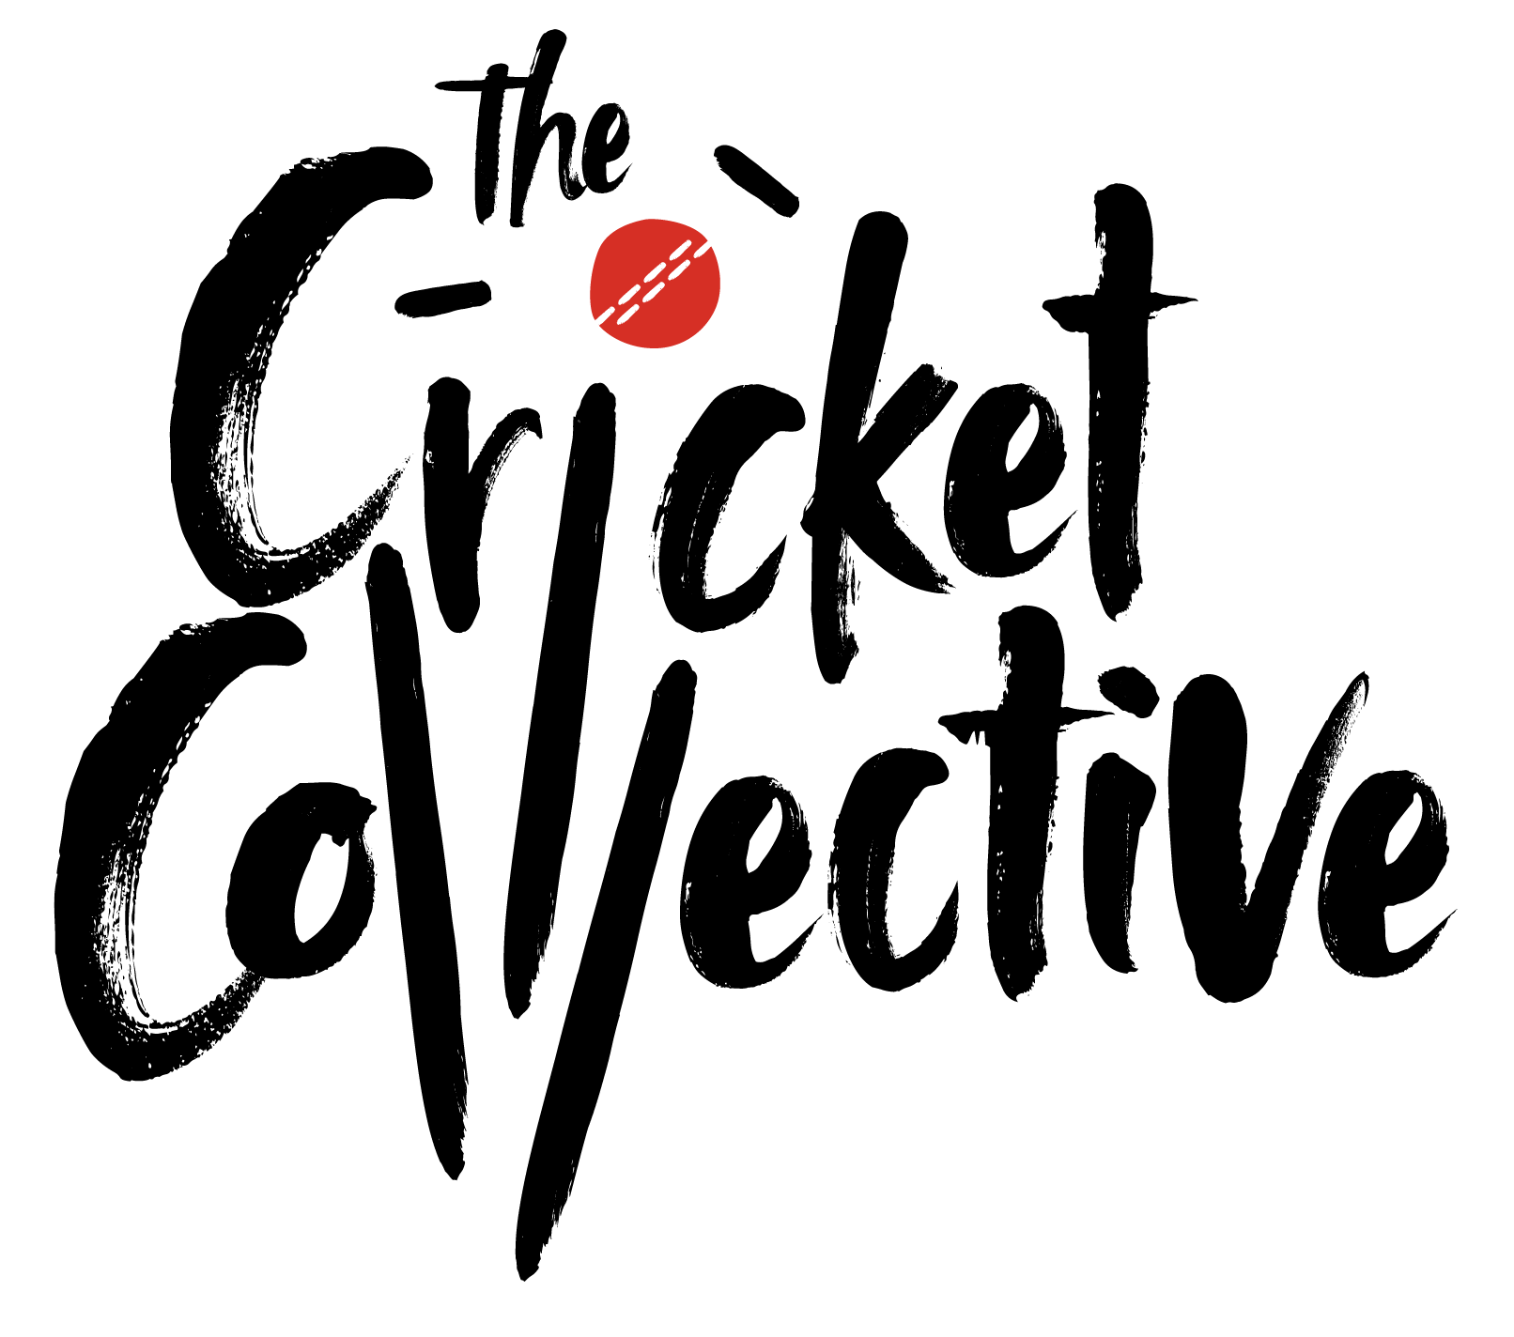
These Role Profiles serve as examples.
Your club should adapt the content to suit your specific situation.
For further guidance, please consult the ECB Volunteer Role Profile Guidance document.

If we can make any reasonable adjustments – or provide additional information and background – to support your application, please let us know.

Join xxx Club as Refreshments Assistant

Main Aim of the Role: | To help visitors enjoy their time at the club by assisting with food and drinks
Time commitment: | Flexible
Useful skills: | - Sociable and welcoming  - Responsible  - Good communicator
Support / training received: | Support from the club volunteer coordinator and wider volunteer team; training on using a till is offered
Tasks: | - Treat club members and visitors in a friendly and welcoming manner  - Serve food and drinks to visitors and take the relevant payment by cash or card  - Clean and tidy the club social area
Benefits of volunteering: | - Learn new and develop existing skills through hands on experience  - Join our thriving and welcoming club community, meet new people and have fun!  - Become part of the Cricket Collective, the volunteers bringing the recreational game to life across England and Wales  - Gain a brilliant CV booster!
How to apply: | - Send an email expressing your interest to xxx@xxx.com

Insert club inclusion statement here

e.g.: XXX club believes in equal opportunities and is committed to developing an inclusive club environment.

If we can make any reasonable adjustments – or provide additional or background information – to support your application, please let us know.

